PROJECT CHARTER

September 21, 2015

Table of Contents

Project Scope
Team Members and Responsibilities
Work Breakdown Structure
Detailed Budget Breakdown
Constraints, Resources, Problems/Risks
Schedule
VoC

Project Scope
The Net-Zero Tiny House is a design and build project with some basic aspects in mind: education, compliance to standards and policies, efficiency, and appeal.
One goal of our project is to create the living laboratory as an educational entity for the community. We want to showcase cutting-edge technology and green building techniques that encourage green living. The mini house will be used by at least 3 different professors at Weber State for education on different aspects including architectural, environmental, and electrical.
Our project is going to be built by the National Green Building Standards. We will also use Passive House guidelines in our construction, and the building will be in compliance with Ogden City.
Along with educating our audience with the project, we want to show that the techniques incorporated in building a net-zero home are doable for the everyday person. We want to show that it is affordable and there is opportunity to use repurposed materials.
Systems:
- Plumbing
- Grey water system
  - Bio swale
  - Electric on-demand water heating
  - (Possible solar water heating system)
- Heating and cooling
  - Rocket stove
  - ERV (Energy Recovery Ventilator)
  - Passive solar
  - Thermal solar
  - Geo-tube
  - Integrated smart home technology
- Electric
  - PV solar
Special Features:
- Solar tube lights
- Rainwater collection
- Educational opportunities
- Sensors, data output on energy usage, pictures and excerpts from build
Interior Layout:
- Bedroom/loft with egress (sleep space)
- Workspace
- Living area
- Kitchen
- Laundry area
- Energy efficient washing machine
Guidelines/Construction:
- National Green Building Standards
- Net-zero HERS rating
- R30 exterior walls
- R60 roof
- Ogden City compliance
- 500 sq ft
- Passive house construction/2x4 offset with double insulation
Aesthetically pleasing while being inexpensive and efficient (repurposed materials)

Team Members and Responsibilities
Faculty Advisor – Jeremy Farner
Project Owners – Julie Rich and Deon Greer
Team Lead – Jason Sylvester
Team lead duties and responsibilities:
- Work with scheduler to set meeting agendas and oversee meeting presentation
- Oversee schematic design, design development, and plans
- Ensure all plans are feasible, workable, and efficient
- Research ideas and usable concepts for net-zero principles
- Oversee design and manufacture of rocket stove
- Exercise final say/approval in event of conflict
- Pick up unforeseen responsibilities
- Delegate and coordinate responsibilities between each individual in group
- Develop a plan on how to ensure the safety of team members and participants
- Compile all material safety documents in a binder (MSDS when needed)
- Identify worksite risk and implement suitable controls
- Implement effective communications across the team
- Implement a process to identify and correct non-conformities with safety

Scheduler – Alexis Sheffield
Scheduler duties and responsibilities:
- Manage and develop detailed and color-coded schedule
- Upload meeting minutes and notes to Google Drive for documentation filing and for group review
- Document action items and have agenda ready for meetings with minutes from previous meeting
- Remind team members of assignments discussed during meeting and add them to schedule
- Work closely with team lead to help with documenting delegation of tasks
- Keep track of progress and changes and update schedule accordingly

Treasurer/Grant Writer – Dewey Lakey

Grant writer/Treasurer duties and responsibilities:

- Research potential funding sources
- Prioritize grant application deadlines
- Compile the information needed
- Compose and send proposals
- Track proposals
- Research, evaluate products and services from companies
- General financial oversight
- Financial planning and budgeting
- Financial reporting
- Banking, book keeping and record keeping

Purchaser – Alex Schreyer
Purchaser duties and responsibilities:
- Obtains requirements by verifying, preparing, and forwarding purchase orders; verifies receipt of items; authorizes payment
- Verify purchase requisitions by comparing items requested to master list; clarifying unclear items; recommending alternatives
- Forwards available inventory items by verifying stock; scheduling delivery
- Prepares purchase orders by verifying specifications and price; obtaining recommendations from suppliers for substitute items; obtaining approval from requisitioning department
- Obtains purchased items by forwarding orders to suppliers; monitoring and expediting orders
- Verifies receipt of items by comparing items received to items ordered; resolves shipments in error with suppliers
- Authorizes payment for purchases by forwarding receiving documentation
- Keeps information accessible by sorting and filing documents
- Provides purchasing planning and control information by collecting, analyzing, and summarizing data and trends
- Updates job knowledge by participating in educational opportunities
- Accomplishes purchasing and organization mission by completing related results as needed

CAD Manager – Burton Scofield
CAD manager duties and responsibilities:
- Initialize a working copy of a CAD and REVIT program representing the team project
- Initiate folder on Google Drive for CAD and Revit files for team project
- Collect all CAD related information from team members on a regular basis
- Incorporate all collected information into the Master CAD and REVIT files for this project
- Maintain final deliverable files for the project
- Archive older CAD files for reference
- Perform clash detection in all areas of CAD drawings submitted by the team, and disseminate problem areas to the team
- Provide updated information to all team members on request
- Develop all elevations, floor plans, electrical plans, plumbing plans, and HVAC plans from information submitted by team members
- Ensure clients are updated with the most current information on the project

Documentation Manager – Benjamin Bartholomew
Documentation manager duties and responsibilities:
- Develop a plan on how to structure our document system
- Compile all documents in a neatly organized, easy-to-use binder
- Create a digital file where all documents can be stored as backup to the hard copy
- Serve as the group’s photographer, creating records with photographs and videos
- Responsible for making sure all documents are gathered, filed, and ready to be turned in on or before due date

Superintendent/Estimator – Forest Allen
Superintendent/Estimator duties and responsibilities:
- Define scope of work
- Complete quantity take offs
- Coordinate with subcontractors and suppliers to get pricing
- Construct preliminary estimate to compare with available funds
- Value engineer expensive aspects of the job for savings
- Construct final estimate
- Create spreadsheet for treasurer to use for documentation of actual cost vs. estimated cost
- Oversee construction progress and quality
- Coordinate between scheduler and subcontractors to ensure timely completion
- Serve as a point of contact for any subcontractor questions
- Coordinate helpers and laborers with supervisor
- Coordinate time on-site with each individual on the team to allow even workload
- Logistics coordination

Electricians – Skylar Peterson, Dale Brendon, Fred Chiou (Faculty)
Electrician duties and responsibilities:
- Design a grid-tied solar PV array capable of supplying all necessary electrical needs as set forth by the project design team
- Install the designed PV system using project funds to meet local and national electrical code standards

Work Breakdown Structure
- Net-Zero Mini House
  - Schedule
    - Scope
    - Size
    - Features
    - Schedule
    - Budget
  - Design
    - Floorplan
    - Loft and Roof
    - Greywater
    - Solar
    - Rocket Stove
  - Build Permit
    - Submit Design
    - Receive Permit
  - Site Preparation
    - Clear site
    - Excavate
    - Clean up
  - Design Systems
    - Greywater
    - Solar
    - Rocket Stove
  - Foundation
    - Get Materials
    - Prepare
    - Footings
      - Form footing
      - Footing inspection
      - Pour footing
      - Strip footing forms
    - Foundation
      - Form foundation
      - Foundation inspection
      - Pour foundation
      - Strip foundation forms
      - Pour concrete slabs
  - Manufacture Systems
    - Get Materials
    - Rocket Stove Manufacture
  - Build House
    - Framing
      - Get materials
      - Frame Walls
      - Frame Roof
    - Exterior
      - Install doors and windows
      - Electrical/Wiring
      - 4-Way inspection
      - Siding
      - Soffit and fascia
      - Roofing
    - Interior
      - Get materials
      - Insulation
      - Drywall
      - Clean up
      - Paint
  - Final Inspection
  - Furnish

Detailed Budget Breakdown

 |  |  |  |  | 2 X 4 X 8
LF WALLS |  | 76 |  |  | 57
CORNERS |  | 4 |  |  | 12
UPPER WALLS |  | 38 |  |  | 28.5
 |  |  |  |  | 97.5 | 204.75 |  | $ 614.25
Floor joist |  | 16 | 22 |  |  |  |  | $ 396.00
Stair Materail |  |  |  |  |  |  |  | $ 400.00
 |  |  |  |  | CONCRETE
FOOTINGS |  | 76 |  |  | 126.6667 | 4.691358 | 5
FOUNDATION |  | 76 |  |  | 304 | 11.25926 | 12
FLOOR |  | 360 |  |  | 4.5 | 4.444444 | 5
Form rental |  |  |  |  | Yards of concrete |  | 22 | $ 3,630.00
Rebar |  |  |  |  |  |  |  | $ 600.00
 |  |  |  |  |  |  |  | $ 400.00
Truss package |  | 1500 |  |  |  |  |  | $ 1,500.00
Plywood | Roof | 667.8 |  |  | 20.86875 | 21 |  | $ 462.00
 | Walls | 76 | 19 | 20.9 |  | 21 |  | $ 273.00
 | floor | 180 | 6.1875 |  |  | 7 |  | $ 203.00
Windows and Doors
 | Doors |  |  |  |  |  |  | $ 1,500.00
 | windows |  |  |  |  |  |  | $ 2,000.00
Plumbing
 | piping |  |  |  |  |  |  | $ 800.00
 | fixtures |  |  |  |  |  |  | $ 400.00
 | toilet |  |  |  |  |  |  | $ 150.00
 | tub |  |  |  |  |  |  | $ 300.00
 | hotwater heater |  |  |  |  |  |  | $ 1,000.00
Electrical
 | boxes and wiring |  |  |  |  |  |  | $ 400.00
 | lighting fixtures |  |  |  |  |  |  | $ 400.00
 | solar panels |  |  |  |  |  |  | $ 6,000.00
fastners |  |  |  |  |  |  |  | $ 500.00
calk and adhesive |  |  |  |  |  |  |  | $ 250.00
sheet rock |  | 608 | 180 | 456 | 450 | 58.23125 | 59 | $ 708.00
Exterior finish |  |  |  |  |  |  |  | $ 5,000.00
flooring |  | 180 | 540 |  |  |  |  | $ 540.00
floor stain |  |  | 600 |  |  |  |  | $ 600.00
Roofing |  | 667.8 | 7.3458 |  |  | 7.5 |  | $ 787.50
Soffit & facia |  |  |  |  |  |  |  | $ 500.00
Geo tube cooler |  |  |  |  |  |  |  | $ 500.00
Grey Water |  |  |  |  |  |  |  | $ 500.00
paint |  |  |  |  |  |  |  | $ 500.00
spray on insulation |  |  |  |  |  |  |  | $ 3,000.00
Building Permit |  |  |  |  |  |  |  | $ 2,500.00
dormer Framing |  |  |  |  |  |  |  | $ 600.00
Equipment Rental |  |  |  |  |  |  |  | $ 700.00
cement pump trucks |  |  |  |  |  |  |  | $ 750.00
Cabinets |  |  |  |  |  |  |  | $ 1,500.00
Applainces |  |  |  |  |  |  |  | $ 1,500.00
Trim |  |  |  |  |  |  |  | $ 400.00
Emergency Heat |  |  |  |  |  |  |  | $ 600.00
Rocket stove or Pellet stove |  |  |  |  |  |  |  | $ 2,000.00
 |  |  |  |  |  |  |  | $ 45,363.75

Constraints, Resources, Problems, Risks
Constraints
- Budget
  - $20,000 + potential grants
- Location
  - Land available, terrain, foliage
- Ogden City compliance
- Size of home
- Time
- Labor
- Weather
  - Winter season, frozen ground
Resources
- Design
  - Design software
- Building
  - Materials (wood, cement, insulation)
  - Hand tools (power drill, hammers)
  - Machinery/tooling (excavator, cement truck, saws)
  - Hardware (nails, screws)
  - Wiring/electrical
  - Repurposed wood
- Systems
  - Solar
    - Ground mount system
  - Greywater
  - Rocket stove
    - Materials
    - Tooling
- Labor
  - Members of project
Problems/Risks
- Running out of funds
- Getting behind schedule
- Design failure

Milestone Summary
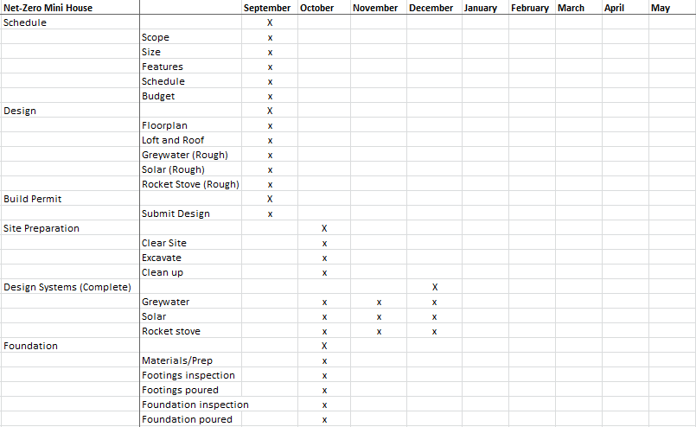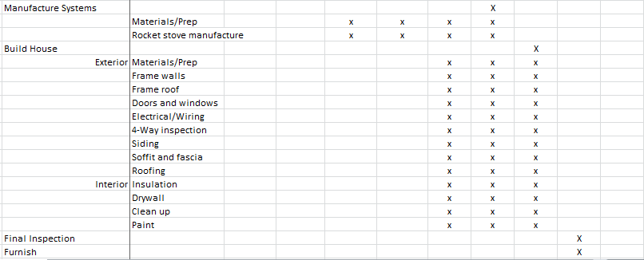

VoC / Specifications Analysis
Our customers are identified as Julie and Deon Rich. Julie is a faculty member at Weber State University. The customers would like to build a net-zero studio in their backyard, in the same location of an existing shed. The proposed footprint is initially 20’ x 20’. The customers would like to incorporate solar panels to provide electrical needs, greywater recapture and rainwater capture to utilize in watering of plants and garden areas. They would like to reuse the wood from the shed as part of interior design material. Components of the studio would include a heating system, and passive cooling. There needs to be a kitchen area with a cooktop and small fridge, a utility sink and a washing machine, a mud room with shower and small sink area, and a living room space with adequate seating for customers and guests. The building should include a loft area for storage and include stairs for access. The building would be used as a demonstration home for students and other guests to evaluate the features incorporated in this mini home. Constraints include a budget, which is set at $20,000.00, but could increase with vendor donations, and possible grants for the project. All requests from the customer can be met with a designed building footprint of 18’ x 20’ and a loft area of 18’ x 9’.

